RESOLUTION NO.__________

RE: CERTIFICATE OF APPROPRIATENESS UNDER THE
PROVISIONS OF THE ACT OF THE PENNSYLVANIA
LEGISLATURE 1961, JUNE 13, P.L. 282 (53
SECTION 8004) AND BETHLEHEM ORDINANCE NO.
3952 AS AMENDED.

WHEREAS, it is proposed to add an additional line of text on the blade sign at 574 Main St.

NOW, THEREFORE, BE IT RESOLVED by the Council of the City of Bethlehem that a Certificate of Appropriateness is hereby granted for the proposal.

Sponsored by: (s)

(s)

ADOPTED BY COUNCIL THIS DAY OF

(s)
President of Council

ATTEST:

(s)
City Clerk

HISTORICAL & ARCHITECTURAL REVIEW BOARD

Walk-in: The applicant is requesting permission to add an additional line of text on the blade sign at 574 Main St.
APPLICATION #2:

Able Pay (John Fistner)
574 Main St.
Bethlehem, PA 18018

518 Main St.
Bethlehem, PA 18018

OWNER:

__________________________________________________________________________

The Board upon motion by Marsha Fritz and seconded by Derrick Clark adopted the proposal that City Council issue a Certificate of Appropriateness for the following:

- To add an additional line of text on the existing blade sign.

2. The motion was unanimously approved.

__________________________________________________________________________

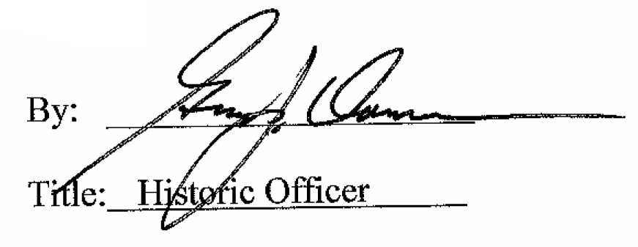

Date of Meeting: February 14, 2018

